Thursday 3/22
Bring Mud Boots!

Weather permitting , our class will be going on the nature trail Thursday 3/22 to tap the sugar maple trees. Hopefully the snow will have melted enough by then.The ground gets muddy so I am asking that each student bring in a pair of boots or old shoes (marked with your child’s name) to wear. Boots will be kept at school until the sugaring project is over. If you do not have boots, send in a pair of shoes that can get muddy (your child will need to change into a clean pair of shoes afterwards). The project will last for 2 - 3 weeks.
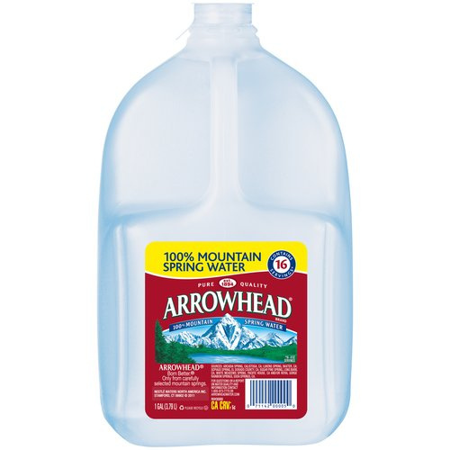We will need SEVERAL gallon water jugs to collect sap in. Please send in any jugs you have. Thank you……..

Sincerely,

Ms. Price

