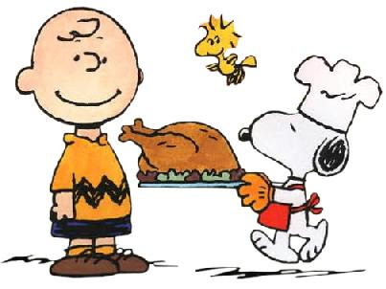
You’re invited to a Kindergarten Friendship Feast!
Please RSVP by 11/15/18. Complete and return this form in your child’s Family Folder.
Who: All Kindergartners and one guest. One family member is invited to attend (there is no room for siblings). We are encouraging a GRANDPARENT to join in the festivities. Please note: we have limited seating in the cafeteria and enough seating capacity for all of our Kindergarten students to attend with one adult only!
Where: Foster School Cafeteria
When: Wednesday, November 21st from 10:00 am to 11:00 am
----------------------------------------------------------------------------------------------------------------------------------------------------------------------------------------------------------
_____ My child will NOT be attending the Friendship Feast.
_____ My child will be attending the Friendship Feast. **

Student’s Name: _______________________________________

Guest’s Name: _________________________________________

** If you would like your child to be dismissed directly from the feast at 11:00 with his/her special guest, please complete the information below.

I give permission for my child _________________________________ to be dismissed at
11:00 am with his/her guest, _________________________________________________.

Parent Signature: __________________________________ Date: _______________

